HOSTEL MANAGEMENT SYSTEM

RISHAV RAJ B170562CS

SHUBHAM ANAND B170305CS

GAURAV KUMAR B170383CS

PRITAM PATEL B170418CS

## 

## ABSTRACT

“HOSTEL MANAGEMENT SYSTEM” is software developed for managing various activities in the hostel. This particular project deals with the problems on managing a hostel and avoids the problems which occur when carried manually.

Our aims is computerization of current procedure of allocating hostel rooms. Currently the process involves students filling up the forms and submitting them in respective hostel offices which involves a lot of paperwork, hence less efficient.

## 

## USER MANUAL

## 1.Home Page

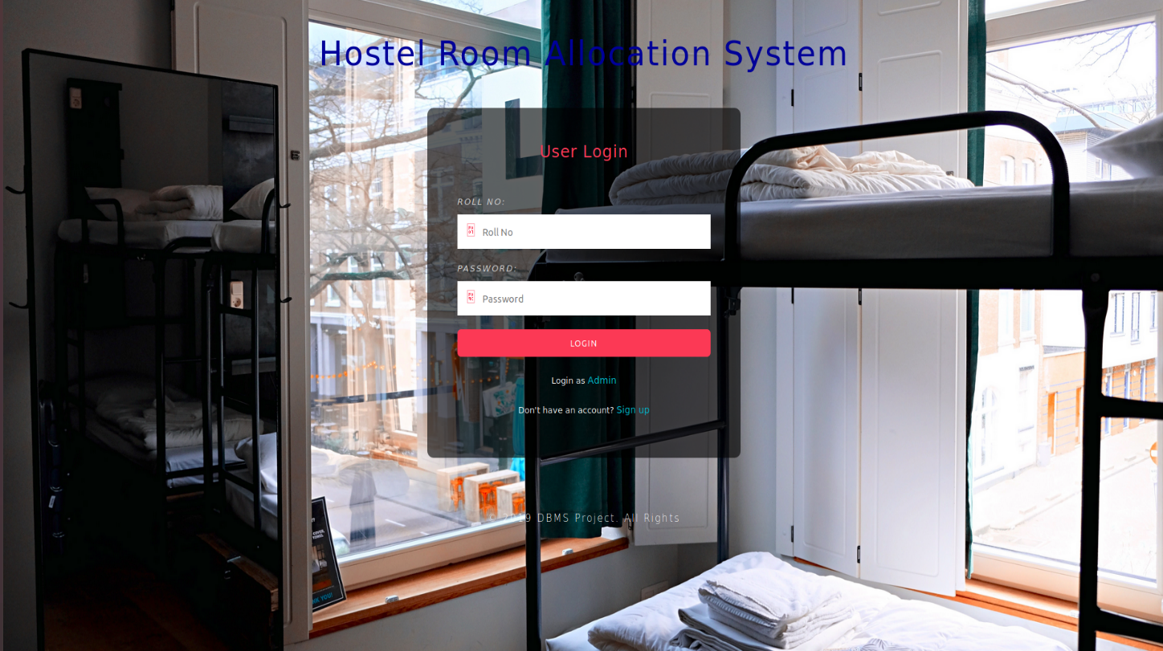

Users who have previously registered for the Hostel Room Allocation System Web Application must login by:

1. Entering their Username/Roll No.
2. Entering their Password.

Selecting Login to advance to the next screen and begin using the application.

There will be a option for signup for new user as well as sign in option for admin.

## 2. Sign Up Page

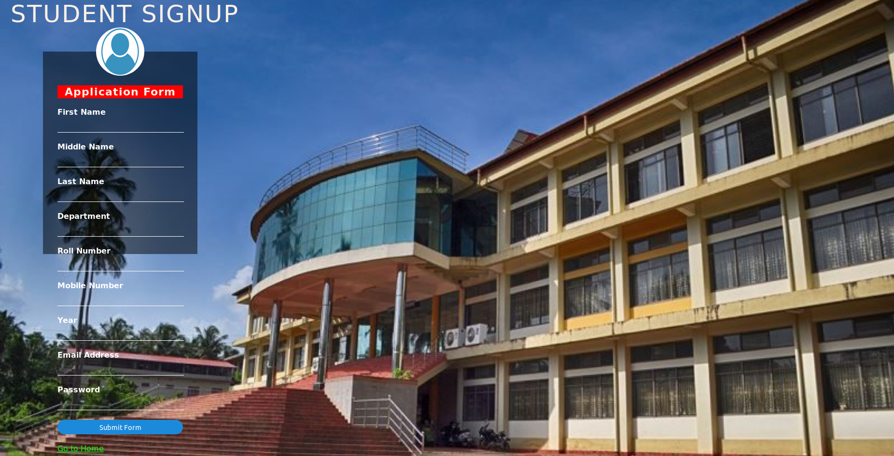

Students who have not previously registered for the Hostel Room Allocation System Web Application must select “Register to use the site” to access the “New User Registration” page.

There they can enter all the required details and register themselves in the portal.

## 3. Admin Page

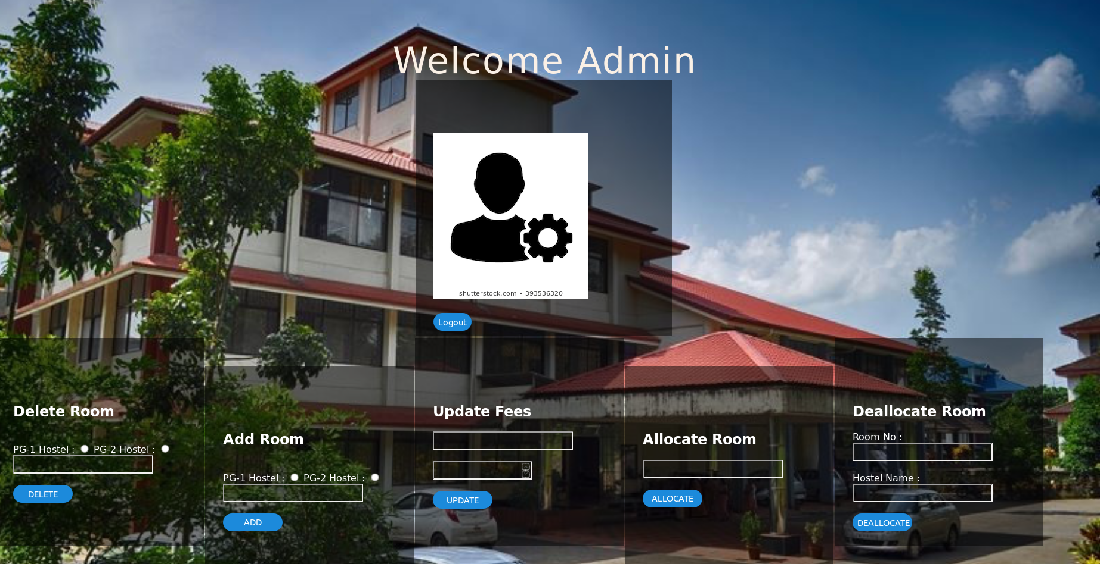

For each hostel, there is a admin.

Admins can add/delete the rooms for their respective hostel.

Admins can allocate/deallocate room and they can also update fee details of student.

## 4. User Home Page

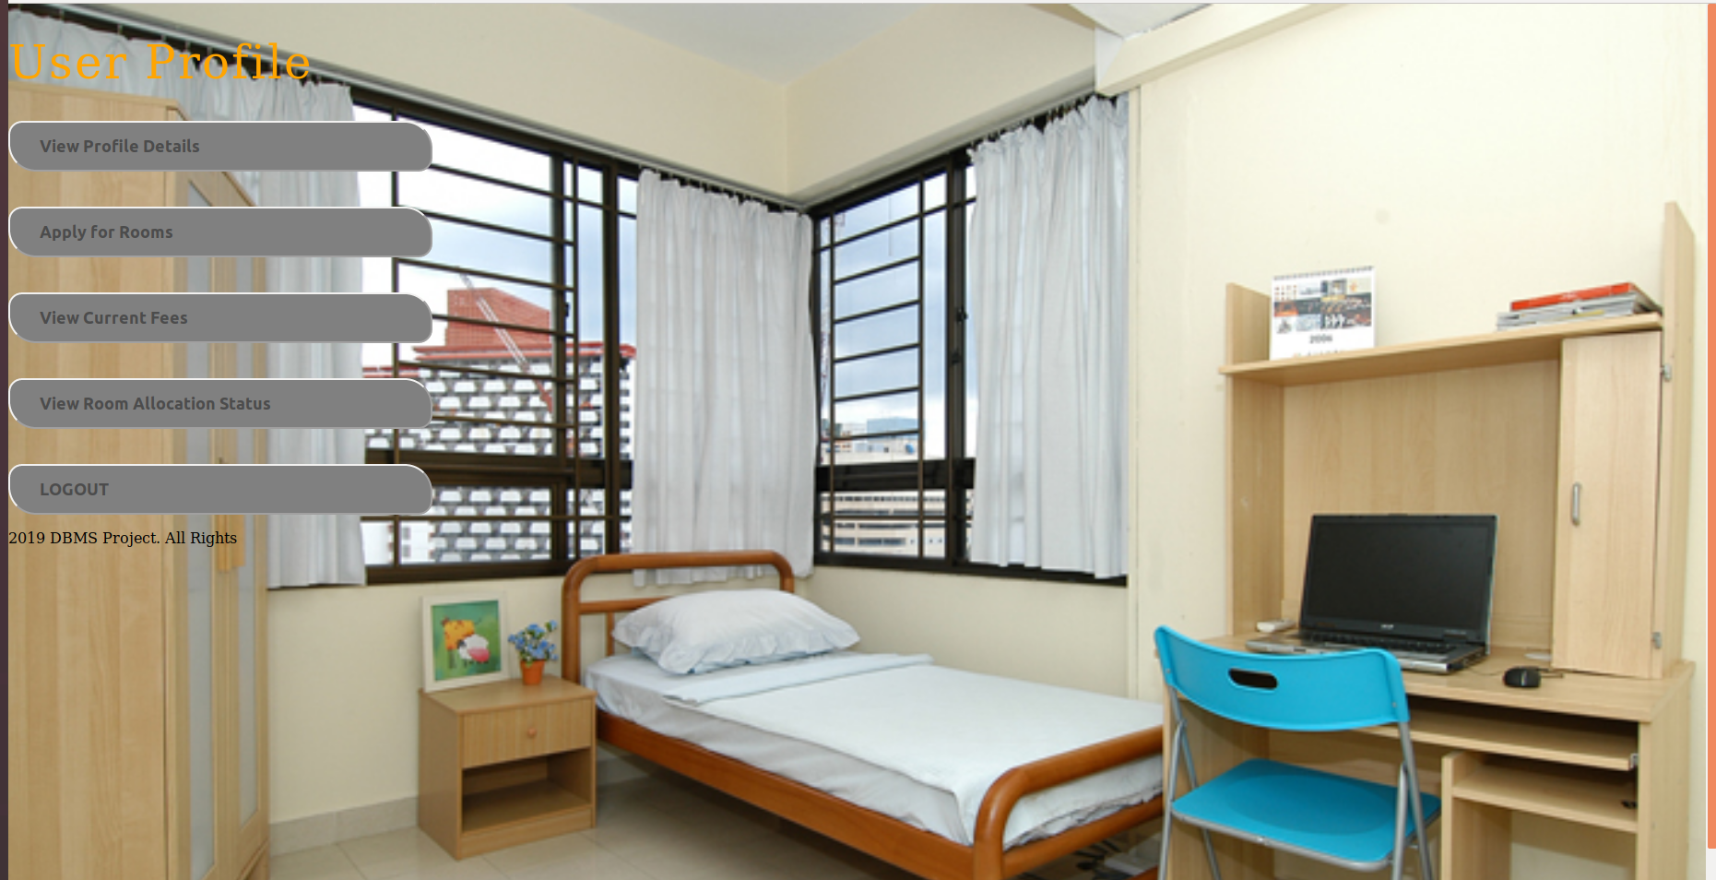

Here, User can see their profile details, current fees, room allocation status and they can apply for room too.

## 5. User Profile

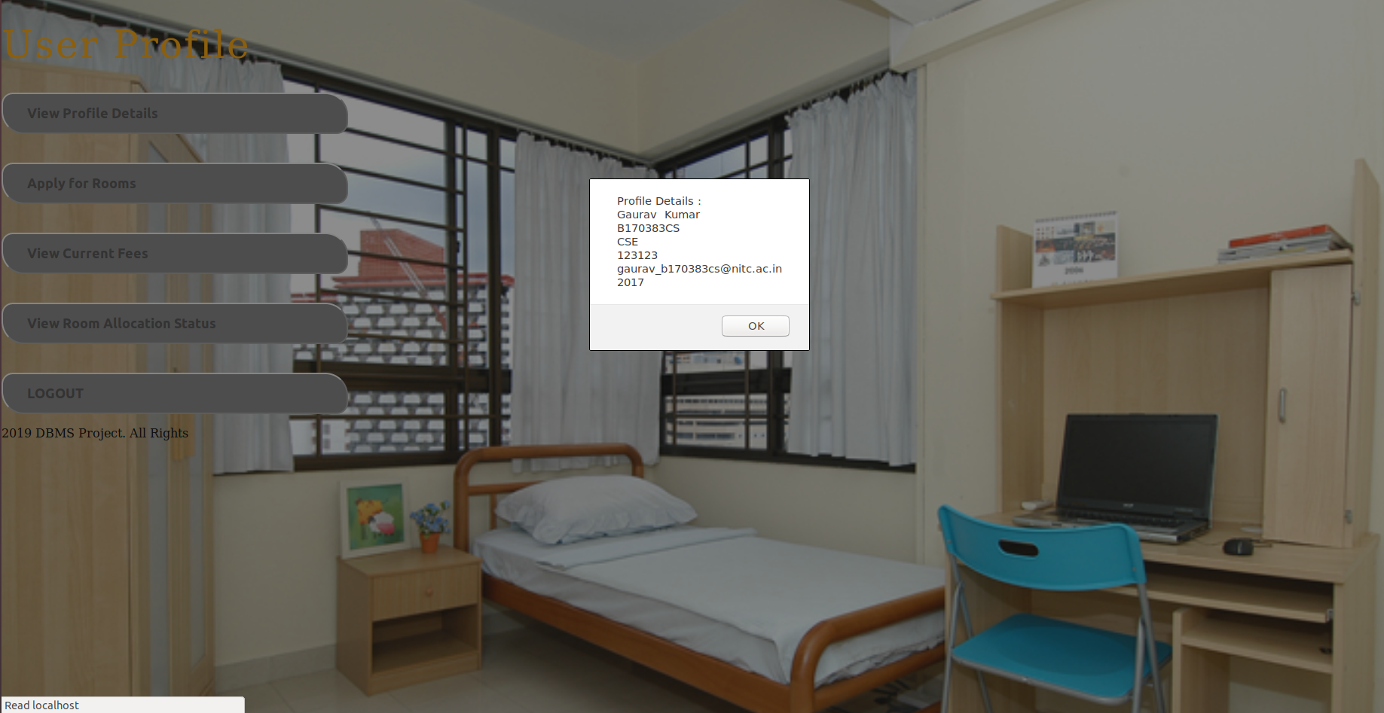

User profile will show name, roll no., branch, email id and year.